1. **What all factors account for the tracking error of the constructed portfolios?**

The number of stocks in the portfolio is one factor that accounts for the tracking error of the constructed portfolio. The larger the number of stocks, higher the probability of a smaller tracking error. Besides, we can consider the correlation of the stocks to the benchmark. If we have uncorrelated stocks to the benchmark in our sample, the tracking error would be higher.

1. **2. What is the relationship between tracking error and portfolio sample size?**

We tend to have smaller tracking errors when we have larger portfolio sample sizes. We can see a substantial difference between the track error of our 5 stock portfolio and our 25 stock portfolio.

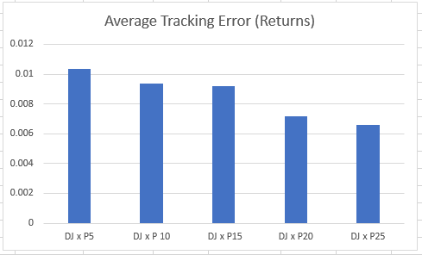

**3. What might be the most optimal way to decrease tracking error without having to construct a full portfolio matching the entire index**

We can try combinations of stocks that, as a group, behave similarly to our benchmark. We can find a portfolio of stocks that, as a group, maximize the correlation to the benchmark.